Monday, 1 March 2021

Dear Parent/Caregivers,

Students may be photographed during activities throughout the year. These photographs may be used in the classroom or for publication, including Facebook, school website etc.

We understand that some parents may choose to opt out of some of these publications.

Please complete the form below and return to the office.

Yours sincerely,
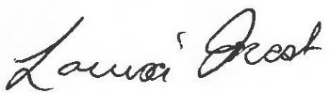

Louisa Frost
Relieving Principal

PHOTOGRAPH PERMISSION

I consent to my child, ………………………… in Year ………………………… to be photographed in the following areas.

Individual:

‘The Guardian’ Yes No ‘The Bridge’, Yes No
‘School Magazine’ Yes No ‘School Web Page’. Yes No
‘Facebook’ Yes No ‘Photostory’ Yes No

I do not allow any photos to be published of my child/children.

Signed: ………………………………………. Date: …………………………..
Parent/Caregiver

