Tuesday, 23 February 2021
Dear Parent
To support and enrich your child’s learning in the classroom, a range of different websites and third party software applications may be used.
- Cars and Stars
https://app.carsandstars.com.au/users/privacypolicy

- Pat Testing (Progressive Achievement Testing)
https://www.acer.org/privacy

- ABC Reading Eggs
https://readingeggs.com.au/privacy

- Tynker
https://www.tynker.com/privacy/

- To support administration processes and student management our school uses SENTRAL. This is used for SMS etc.
https://www.sentral.com.au/privacy-policy/

Please complete the note below if you wish to give your child permission to uses these programs in the classroom. If you have any questions or queries please contact me or your child’s teacher.
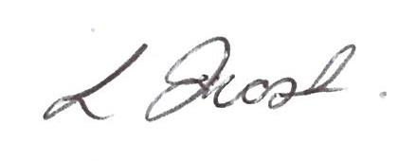
Yours sincerely

Louisa Frost
Relieving Principal

Opt Out Third Party Computer Software
I do not give permission for my child …………………………….. in Year ……………. to have their information in following programs.
- Cars and Stars
- Pat Testing (Progressive Achievement Testing)
- ABC Reading Eggs
- Typing Club
- Tynker
- Sentral
Signed: …………………………………………………… Date: …………………………
Parent/Caregiver

